 Instruction for replacement SSD card.
*Note: If you have inputs/relays connected, they may go off during this reinstallation.

- Unplug the power cable and all cables from the back of IP108 or IP100.
- Remove IP108/100 from rack and place in an antistatic work environment to complete this work.
- Take the top cover off (5 screws on top and 2 screws on each side).
Use P1 size screwdriver and use caution removing screws
- Gently replace SSD (Solid-State Drive) (1 screw).
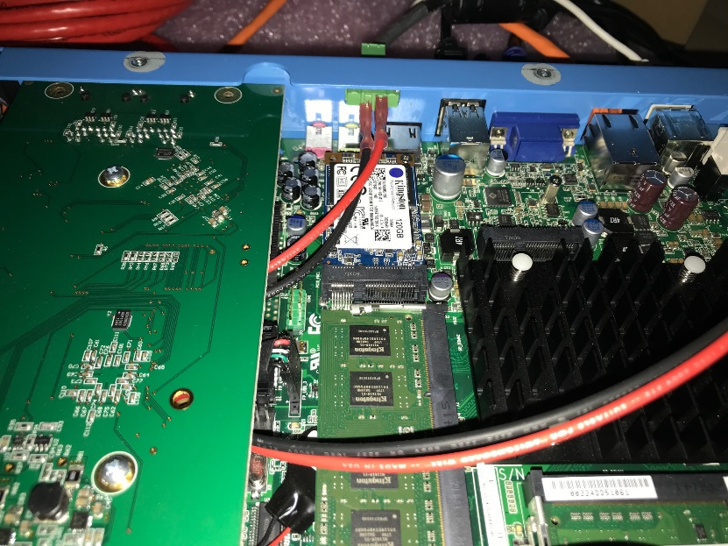
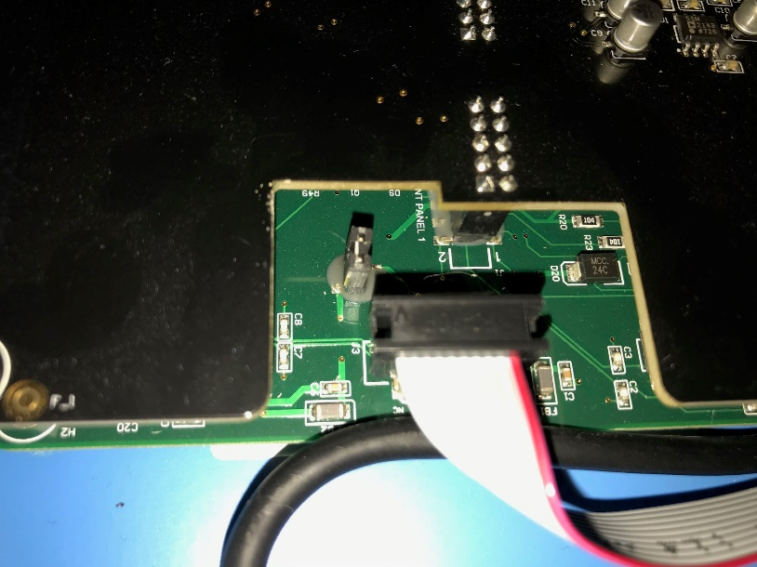
- Remove ribbon cable from the bottom of relay board and the jumper right next to it too.
- Remove cable from LCD display.

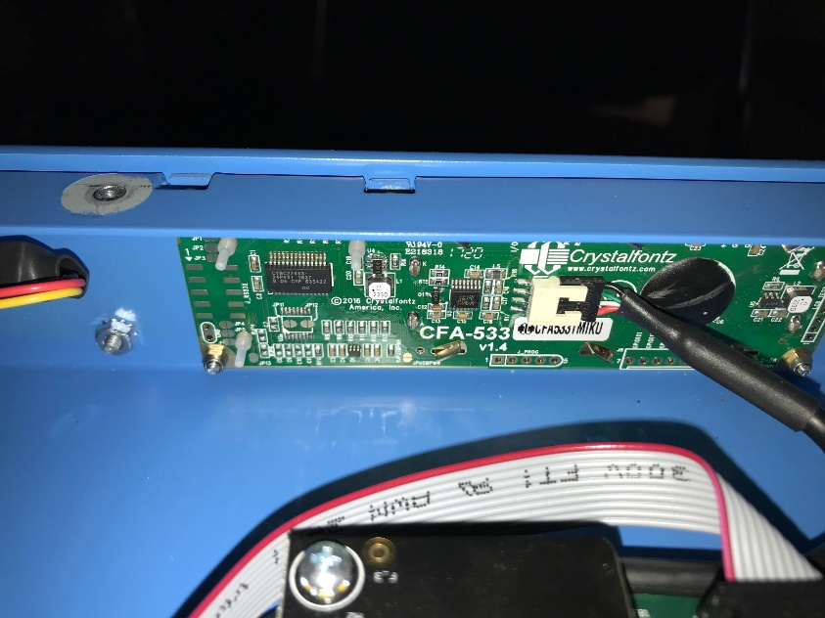
- Apply the power to the unit back with a monitor, keyboard and mouse and hold “DEL” key to enter the BIOS mode.
If the unit does not power up short the two exposed red pins for the front panel header, edge side of RAM
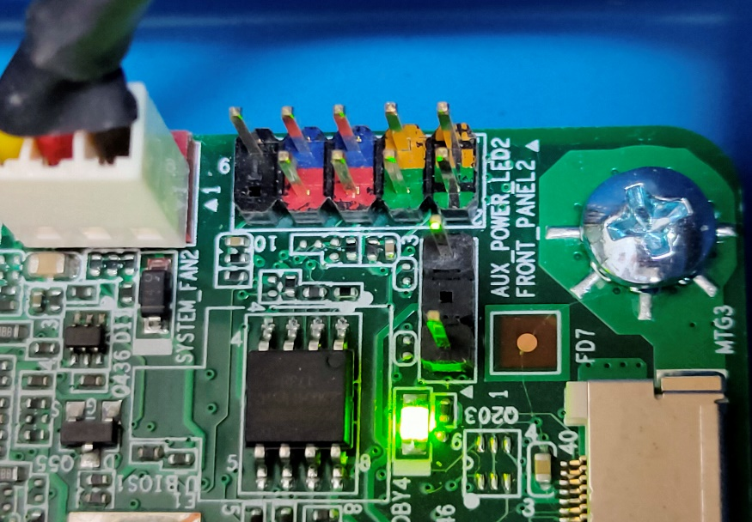
- Go to “Save & Exit” tab and use the arrow key down to scroll to “Restore Windows 8-64 or 8/10-64 bits Defaults” and click “Enter”.
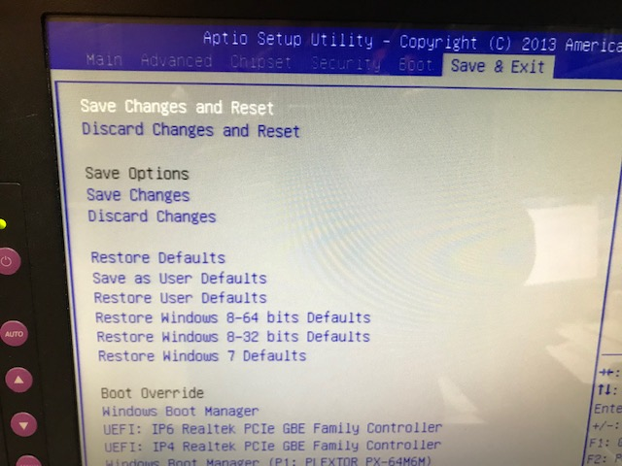
- Choose “Yes” and click “Enter” again.
- Click on the Boot tab and change the boot order to 1.USB Key 2. Hard drive
- Go to “Chipset” tab make sure the Panel type is set to LVDS and scroll down to “Restore AC Power Loss”. Click “Enter” and choose “Power On” option.

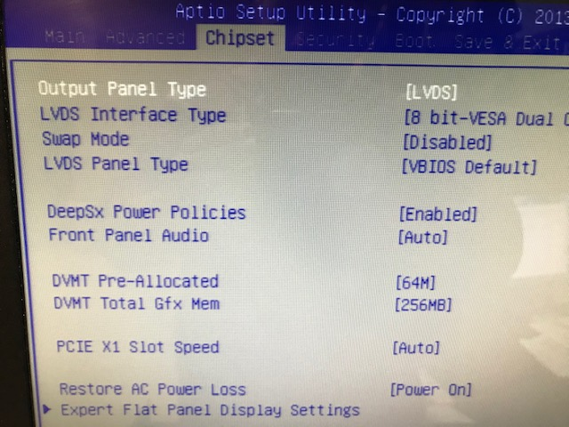

- Press F4 key to save and exit. Confirm by chosen “Yes”.
- The controller will reboot. Wait for windows to boot up. (The login is:12345ied”)
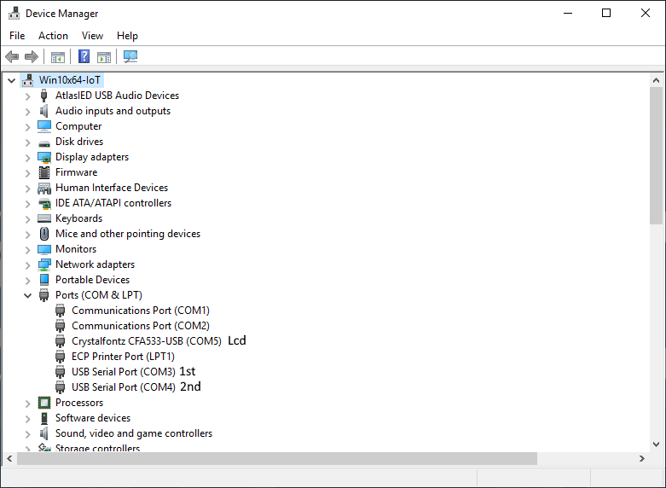
- Open the Device Manager
- Plug in the ribbon cable 1st and COM3 will pop up
- Now put the shunt back on to the header and COM4 will pop up
- Plug in the LCD cable and COM5 will pop up
- At this point you can put the top cover back on to the controller
- Open GCK software by double click on “GCK System Management Center” icon on desktop
- Click on “login”. Type “gck_admin” for username and password.
- Check the license status at the bottom right. If the license shows “Inactive” click on “Update License” and click on “Send Activation File” and navigate to the copy of your “*.lfx” license file on desktop or contact AtlasIED.
- Complete any self-testing at this point
- Disconnect monitor, keyboard and mouse and replace into rack and reinstall

